During the Medica fair in Düsseldorf, the new Executive Committee of the European Association of Hospital Managers (EAHM) held its first meeting since the elections of September 2018 in Cascais.
On this occasion the new Board of the association was elected. The members of the board are:
• Philippe Blua, President (France)
• Mieczyslaw Pasowicz, Vice President (Poland)
• Gerry O'Dwyer, Past President (Ireland)
• Nikolaus Koller, Treasurer (Austria)
• Freddy Iemants, Member (Belgium)
• Heinz Koelking, Member (Germany)
• Alexandre Lourenço, Member (Portugal)
• Georgia Oikonomopoulou, Member (Greece)
The new Secretary General of EAHM, Marc Hastert (Luxembourg), will attend the meetings of the Board as an assistant member.

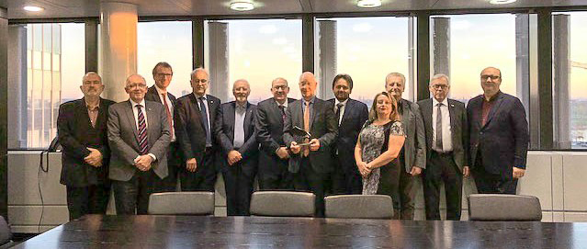
It was the last meeting of the current Secretary General, Mr Willy Heuschen. The members of the Executive Committee thanked Mr Heuschen with a modern sculpture for his good work during the last twenty years on European level.

In Düsseldorf the Executive Committee adopted also its workprogram for the next four years. The following points are among the announced priorities:
• The desire to work closely with the EU authorities to defend the European hospital model, which is based on quality and high-tech treatments, to avoid inequities of health and care, on the predominance of non-profit institutions, as well public or private.
• The wish to develop exchanges between European directors by setting up new thematic working groups.
• The creation of an annual award for innovative hospital projects to encourage the good practices dissemination.
• The development of reflection on the impact of New Information and Communication Technologies on the operational level in hospitals.
• The publication of comparative data between the different European hospital systems.
In addition, the dates of the next congresses have been confirmed:
• 12, 13, 14 September 2019 in Ghent.
• September 30th and October 1st and 2nd, 2020 in Budapest.
********
EAHM was founded in 1970. It gathers 20 associations representing 19 European countries and 16000 members. The association is registered in Strasbourg. Its General Secretariat is located in Luxembourg.
Website: eahm.eu.org. EAHM is also present on Twitter and Facebook

